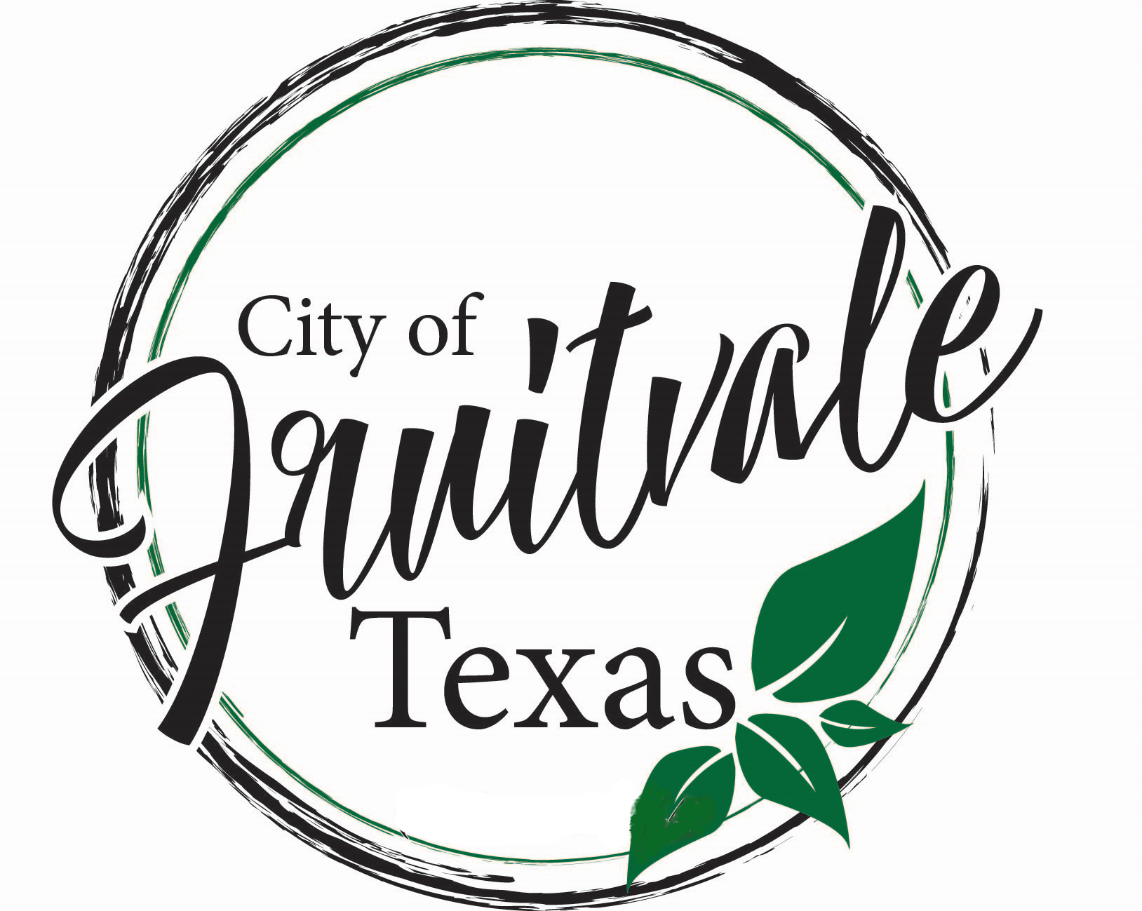
ORDINANCE NO. 12.14.2021.2
AN ORDINANCE OF THE CITY OF FRUITVALE, TEXAS, ESTABLISHING A PERMIT/LICENSE FEE AND ANNUAL PROCESSING AND INSPECTION SURCHARGE PERTAINING TO ARTICLE II. SALE AND PURCHASE OF ALCOHOLIC BEVERAGES IN CHAPTER 4. OF THE CODE OF ORDINANCES OF THE CITY OF FRUITVALE, TEXAS TO REGULATE THE SALE OF BEER, WINE, AND ALCOHOLIC BEVERAGES WITHIN THE CITY OF FRUITVALE; PROVIDING FOR AN EFFECTIVE DATE AND PROVIDING FOR THE PUBLICATION OF THIS RESOLUTION.

WHEREAS, the City of Fruitvale, Texas (the “City”) is responsible for supporting and promoting the health, safety and welfare of its citizens;

WHEREAS, pursuant to Texas Local Government Code section 51.001, the City Council of The City of Fruitvale, Texas (“City Council”) may adopt an ordinance, rule or police regulation that is for the good government, peace or order of the City or for the trade and commerce of the City, and is necessary or proper for carrying out a power granted by law to the City or one of the City’s offices or departments;

WHEREAS, pursuant to Texas Local Government Code section 51.012, the City Council may adopt an ordinance, act, law, or regulation, not inconsistent with state law, that the City Council considers necessary for the government, interest, welfare, or good order of the City as a body politic;

WHEREAS, pursuant to Texas Alcoholic Beverage Code sections 11.38 and 61.36 the City of Fruitvale may adopt a resolution to collect permit and/or license fees for issuing a permit or license to operate, conduct, and maintain a business establishment selling alcoholic beverages in the City;

WHEREAS, a local option ballot election may be held and the voters may elect to permit the sale of beer and wine for off-premise consumption only within the city limits of the City of Fruitvale;

WHEREAS, the City Council has determined that the fees associated with regulating the sale of alcoholic beverages within the City of Fruitvale shall be established as set forth below.

WHEREAS, the City Council has determined that they will only issue a total of 3 permits within the city limits, and that applications beyond that amount will be decided by the City Council on a case by base basis.

NOW, THEREFORE, BE IT RESOLVED BY THE CITY COUNCIL OF THE CITY OF FRUITVALE, TEXAS:
The following fees shall apply to all permits and/or licenses issued pursuant to State law and the City of Fruitvale Code of Ordinances Article II., Chapter 4. Sale and Purchase of Alcoholic Beverages:
Sec. 1. Fees Established.

(A) License and Permit Fee. The annual permit fee for issuing a permit to operate, conduct, and maintain a business establishment selling beer and wine alcoholic beverages for off-premises consumption only in the City shall be $150.00, which is subject to change according to the fees established in the Texas Alcoholic Beverage Code, as amended.

Sec. 2 Annual Processing and Inspection Surcharge Established.
The annual processing and inspection surcharge shall be $100.00. This annual processing and inspection surcharge will offset City administrative expenses related to the regulation of alcoholic beverages within the City.

Sec. 3. Effective Date. This Resolution shall become effective immediately upon its passage and publication according to state law, and it is accordingly so resolved.

Sec. 4. Publication. The City Secretary of the City of Fruitvale, Texas is hereby directed to publish this Resolution in the local newspaper as soon as practicable and as according to law.
DULY PASSED AND APPROVED BY THE CITY COUNCIL OF THE CITY OF FRUITVALE, TEXAS, on this 9th day of November, 2021.

Vicki Ferguson, Mayor

ATTEST:

__________________________
Susan Murre, City Secretary

