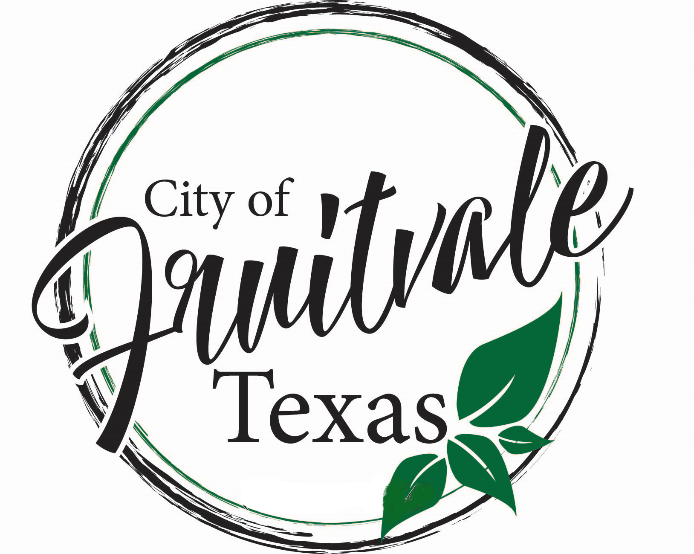
ORDINANCE NO. 11.09.2021
AN ORDINANCE OF THE CITY OF FRUITVALE, TEXAS, ESTABLISHING ARTICLE II. SALE AND PURCHASE OF ALCOHOLIC BEVERAGES IN CHAPTER 4. OF THE CODE OF ORDINANCES OF THE CITY OF FRUITVALE, TEXAS TO REGULATE THE SALE OF BEER AND WINE ALCOHOLIC BEVERAGES WITHIN THE CITY OF FRUITVALE; AUTHORIZING A CITY PERMIT/LICENSE FEE AND PROCESSING AND INSPECTION PROCEDURES; PROHIBITING THE SALE OF BEER AND WINE IN RESIDENTIAL AREAS; ESTABLISHING THE HOURS OF OPERATION; PROVIDING FOR AN EFFECTIVE DATE, REPEALER, PENALTY CLAUSE AND SEVERABILITY CLAUSE; AND PROVIDING FOR THE PUBLICATION OF THIS ORDINANCE.

WHEREAS, the City of Fruitvale, Texas (the “City”) is responsible for supporting and promoting the health, safety and welfare of its citizens;

WHEREAS, pursuant to Texas Local Government Code section 51.001, the City Council of the City of Fruitvale, Texas (“City Council”) may adopt an ordinance, rule or police regulation that is for the good government, peace or order of the City or for the trade and commerce of the City, and is necessary or proper for carrying out a power granted by law to the City or one of the City’s offices or departments;

WHEREAS, pursuant to Texas Local Government Code section 51.012, the City Council may adopt an ordinance, act, law, or regulation, not inconsistent with state law, that the City Council considers necessary for the government, interest, welfare, or good order of the City as a body politic;

WHEREAS, pursuant to Texas Alcoholic Beverage Code sections 61.36 and 109.32, the City Council may adopt an ordinance regulating the sale of beer and wine within the City;

WHEREAS, a local option ballot election may be held and the voters may elect to permit the sale of beer and wine for off-premise consumption only within the city limits of the City of Fruitvale;

WHEREAS, the City Council of the City of Fruitvale, Texas has determined that Article II. Sale and Purchase of Alcoholic Beverages should be established in Chapter 4 of the Code of Ordinances of the City of Fruitvale, Texas to regulate the sale of alcoholic beverages as set forth below.

NOW, THEREFORE, BE IT ORDAINED BY THE CITY COUNCIL OF THE CITY OF FRUITVALE, TEXAS:
The following provisions should be established and will amend the City of Fruitvale, Texas Code of Ordinances as follows:

ARTICLE II. SALE AND PURCHASE OF ALCOHOLIC BEVERAGES

Div. 1. Generally
Sec. 4.1. Purpose.

The purpose of alcoholic beverage regulations is to protect the public health, safety and public welfare.
Sec. 4.2. Definitions.
(A) For the purposes of this article, all definitions of words, terms and phrases as set forth in the Texas Alcoholic Beverage Code are adopted and made a part of this article.

(B) “Business” means an establishment, including but not limited to a general merchandise or food store and/or shop of any size or motor vehicle fueling station, filling or service station engaged in the selling of beer and/or wine to the general public for off-premises personal or household consumption and rendering services incidental to the sale of such goods.

(C) “Permit” means an authorization granted by the City of Fruitvale (“City”) for the sale of alcoholic beverages within the City.
(Ordinance 11.09.2021.2)
State law references: Definitions, V.T.C.A., Alcoholic Beverage Code, section 1.04.
Div. 2. PERMITS

Sec. 4.3. Permit Required.

It shall be unlawful for any person to manufacture, distill, brew, sell and/or possess for the purpose of sale any beer, wine or other alcoholic beverage, or otherwise engage in any activity for which a license or permit is required by the Texas Alcoholic Beverage Code, as amended, within the City, unless the person has a current and unrevoked permit issued by the City.

(Ordinance 11.09.2021.2)

Sec. 4.4. Fees Established.

(A) Permit Fee. The annual permit fee for issuing a permit to operate, conduct, and maintain a business establishment selling alcoholic beverages in the City shall be in an amount that does not exceed one-half (50%) of the State fee for which an alcoholic beverage permit is required under the Texas Alcoholic Beverage Code, as amended. The permit fee shall be established by resolution of the City Council.

(B) The City adopts those exemptions from the permit fee requirement as provided in the Texas Alcoholic Beverage Code, section 11.38(d).

(C) License Fee. The annual license fee for a business establishment selling alcoholic beverages in the City shall be in an amount that does not exceed one-half (50%) of the State fee for which an alcoholic beverage license is required under the Texas Alcoholic Beverage Code, as amended. The license fee shall be established by resolution of the City Council.

(Ordinance 11.09.2021.2)

Sec. 4.5. Payment of Fees.

All fees required under this Ordinance shall be paid in advance to the City Secretary for a one (1) year term at the same time that the State annual fee is due and payable for each respective license and/or permit, including renewals thereof.

(Ordinance 11.09.2021.2)

Sec. 4.6. Issuance of Permit.

(A) The City Secretary shall, in the name of the City, issue and deliver to such applicant or person a permit (a receipt evidencing payment of the fee(s) shall be sufficient proof of a City permit) to engage in a business that sells alcoholic beverages within the City of the character described in and authorized by the State permit or license held by such applicant or person. This permit issued in the name of the City shall authorize the conduct of such business upon the premises described in the State permit or license, and shall remain in force only so long as the State permit or license remains in force. The City permit will be issued upon payment to the City Secretary of the applicable fee(s) for a permit or license as required by this Ordinance and according to State law. The City Secretary shall keep a record of all permits and/or receipts issued under this Ordinance

(B) The permit shall be valid only for one (1) year from the date of its issuance. All permits issued for the payment of permit or license fees under the terms of this Ordinance shall terminate at midnight on the day before the anniversary date of their issuance, and no receipt shall be issued covering a longer term than one (1) year. Upon expiration of any permit issued under this Ordinance, the applicant or person shall renew annually thereafter during the time that such person is engaged in the business of selling alcoholic beverages within the City.
(C) Permit applications shall be filed with the City Secretary.
(D) All permits or licenses issued under this Ordinance shall be displayed in a conspicuous place at all times on the premises for which the permit or license is issued.
Sec. 4.7. Cancellation and Suspension of Permits.
A permit issued under this Ordinance may be cancelled, denied or revoked as provided under Chapters 11 or 61 of the Texas Alcoholic Beverage Code, as amended. The City shall have all powers, duties and remedies permitted under State law.

Sec. 4.8. Annual Processing and Inspection Surcharge.
An annual processing and inspection surcharge in an amount to be established by resolution of the City Council shall be charged by the City Secretary for accepting any application or renewal for which the permit fee is $100.00 or less. The City Secretary shall issue a receipt for the processing and inspection surcharge and keep a record of the same in the city secretary's office. All receipts issued for the payment of a processing and inspection surcharge under the terms of this section shall terminate at midnight on the day before the anniversary date of the permit issuance, and no receipt shall be issued covering a longer term than one (1) year.
The annual processing and inspection surcharge will offset City administrative expenses.
(Ordinance 11.09.2021.2)
Sec. 4.09. Violations and Penalties.
A licensee or permittee who sells an alcoholic beverage without first having paid the fees levied under State law and this Ordinance, or who fails to pay the full amount of the fees levied under this Ordinance when due, commits a misdemeanor punishable by a fine of not less than $10.00 nor more than $200.00. Each day the violation exists shall constitute a separate offense. This penalty shall be in addition to all other remedies provided herein. Any violation of this Ordinance may be used as grounds for cancellation, suspension or denial of a permit.
State law reference–Local fee authorized, V.T.C.A., Alcoholic Beverage Code, sec. 11.38 and 61.36; Recommendation of local officials, V.T.C.A., Alcoholic Beverage Code, sec. 11.41.
Div. 3. General Requirements.

Sec. 4.10. Sale of Beer and/or Wine in Residential Area Prohibited.

The sale of beer and/or wine is prohibited at a location that is within residential areas or within residential zoning districts where residential uses are allowed. Residential areas include properties that allow vertical mixed use developments with a residential component. The following exception will be in place: While there is a mixture of residential and business, the City Council has decided to limit the area where businesses selling alcohol can be located. It shall be established that businesses selling alcohol can only be between the 12624 block of U.S. Hwy 80 to 11690 U.S. Hwy 80, on the north side of the highway.
State law reference–Authority of municipality to regulate sale of beer, V.T.C.A., Alcoholic Beverage Code, sec. 109.32.

Sec. 4.11. Hours of Sale-Beer or Wine.
(A) Beer and/or wine shall not be sold, offered for sale, or delivered at any time not permitted by this section.
(B.1.) Monday through Saturday: Beer and/or wine may be sold, offered for sale, or delivered between 7 a.m. and midnight on any day except Sunday.
(B.2.) Sunday: Beer and/or wine may be sold, offered for sale, or delivered between 10:00am and midnight.
(C) Penalty. A person commits an offense if the person sells or offers for sale an alcoholic beverage during prohibited hours or consumes or permits the consumption of an alcoholic beverage on the person's licensed or permitted premises during prohibited hours. An offense under this section is a Class A misdemeanor.

Sec. 4.12. No Outside Consumption.

(A) It is prohibited for persons, including customers, to leave the premises with open alcoholic beverages and it is the permittee/licensee’s responsibility to ensure that no open alcoholic beverages are sold and carried out.

(B) It is prohibited for persons, including customers, to gather outside an establishment selling alcoholic beverages and consume alcoholic beverages.

(C) It is prohibited for the manager or any employee to allow persons, including customers, to gather outside the property boundaries of an establishment selling alcoholic beverages and consume alcoholic beverages.
(D) Penalty for Violation. A person commits an offense if the person knowingly consumes liquor, beer or wine on the premises of a holder of a wine and beer retailer's off-premise permit or a retail dealer's off-premise license. A person is presumed to have knowingly violated this provision if the permittee/licensee has the warning sign displayed on the premises as required by either section 26.05 or 71.10 of the Texas Alcoholic Beverage Code, as amended. A violation of this provision is a misdemeanor punishable by a fine of not less than $25.00 nor more than $200.00, unless a person has been convicted of a violation of this provision occurring within one (1) year of a subsequent violation. In this case, the subsequent violation is a misdemeanor punishable by a fine of not less than $100.00 or more than $200.00.
(E) Consumption at Public Events. It shall be unlawful for any person to posssess, transport, or consume any alcoholic beverages, as defined by the Texas Liquor Control Act, at any school athletic contest, at any school-sponsored dance, party, or other social gathering or on the grounds or in the building of any public school. Any police officer is authorized to seize and confiscate such alcoholic beverages. Violations of this ordinance shall be a misdemeanor.
(F) Consumption in a Public Place. It shall be illegal for any person or persons to consume alcoholic beverages in public or possess open containers of alcoholic beverages in public within the confines of the City.
(G) Intoxication. Whoever in this City shall get drunk, or be found in a state of intoxication, in any public place, street, alley, highway, or thoroughfare shall be deemed guilty of a misdemeanor.
(H) Intoxicating Liquor to Minors. Any person in the City who sells or gives to a minor any alcoholic beverages shall be deemed guilty of a misdemeanor.
State law reference— Consumption of alcoholic beverage on premises licensed for off-premises consumption, V.T.C.A., Alcoholic Beverage Code, sec. 101.72; Warning sign required, V.T.C.A., Alcoholic Beverage Code, sec. 26.05 and 71.10.

Sec. 4.13. Warning Sign Required.
(A) Each permittee of a wine and beer retailer's off-premise permit shall display in a prominent place on his/her premises a sign stating in letters at least two inches high: IT IS A CRIME (MISDEMEANOR) TO CONSUME WINE OR BEER ON THESE PREMISES.
(B) A permittee who fails to comply with this provision commits a misdemeanor punishable by a fine of not more than $25.00.
State law reference—Warning sign required, V.T.C.A., Alcoholic Beverage Code, sec. 26.05.
Sec. 4.14. Certain Establishments Prohibited.

A business that derives seventy-five percent (75%) or more of its gross revenue from the on-premises sale of alcoholic beverages is prohibited from operating within the City, in accordance with section 109.57(d) of the Texas Alcoholic Beverage Code, as amended.
State law reference—Application of code; other jurisdictions, V.T.C.A., Alcoholic Beverage Code, sec. 109.57.
Sec. 4.15. Failure to Require and Properly Check Identification.

(A) All permittees, licensees, and/or their employees shall require and properly check identification before selling any alcoholic beverage to any customer to ensure an underage person is not sold and/or does not have in his/her possession, alcoholic beverages while in a licensed business.

(B) “Identification” in this section shall mean any document issued by a governmental agency containing a description of the person, such person’s photograph and giving such person’s date of birth and shall include, without being limited to, a passport, military ID card, driver’s license or state department of public safety ID card.
State law reference—Sale to minors, V.T.C.A., Alcoholic Beverage Code, sec. 106.03.

Sec. 4.16. Penalty; Other Remedies.
(A) Any person violating or failing to comply with any of the provisions of this Ordinance shall be fined, upon conviction, not less than one dollar ($1.00) nor more than five hundred dollars ($500.00), unless the violation involves fire safety, zoning, or public health and sanitation then the person shall be fined an amount not to exceed two-thousand dollars ($2,000.00). Each day any violation or noncompliance continues shall constitute a separate and distinct offense. The penalty provided herein shall be cumulative of other remedies provided by State Law, and the power of injunction as provided in sections 54.012 and 54.016 of the Texas Local Government Code, as may be amended, may be exercised in enforcing this Ordinance whether or not there has been a complaint filed.
(B) The penal provisions imposed under this section are cumulative of all other remedies and non-exclusive. These penal provisions shall not be deemed nor construed to limit the availability of any remedy against any person or property otherwise provided by law including without limitation fines, penalties, closure, and injunction. The City retains all legal rights and remedies available to it pursuant to local, state and federal law.
(C) A person who violates a provision of this Ordinance in which a specific penalty is not provided, is guilty of a misdemeanor and, on conviction, is punishable by a fine of not less than one-hundred dollars ($100.00) nor more than one-thousand dollars ($1,000.00) or by confinement in the county jail for not more than one (1) year or by both. The term "specific penalty," as used in this section, means a penalty that might be imposed as a result of a criminal prosecution.
State law reference—General enforcement authority of municipalities, V.T.C.A., Local Government Code, secs. 54.001, 54.012 and 54.016; General Penalty, V.T.C.A. Alcoholic Beverage Code, sec. 1.05.
Sec. 4.17. All permit fees and other fees adopted by the City, as amended, shall remain applicable to the regulations adopted by this Ordinance.

Sec. 4.18. Repealer. All ordinances, orders or resolutions heretofore passed and adopted by the City Council of the City of Fruitvale, Texas, are hereby repealed to the extent that said ordinances, orders or resolutions, or parts thereof, are in conflict herewith.

Sec. 4.19. Severability. If any section, subsection, clause, phrase or provision of this Ordinance, or the application thereof to any person or circumstance, shall to any extent be held by a court of competent jurisdiction to be invalid, void or unconstitutional, the remaining sections, subsections, clauses, phrases and provisions of this Ordinance, or the application thereof to any person or circumstance, shall remain in full force and effect and shall in no way be affected, impaired or invalidated.

Sec. 4.20. Effective Date. This Ordinance shall become effective immediately upon its passage and publication according to state law, and it is accordingly so ordained.

Sec. 4.21. Publication. The City Secretary of the City of Fruitvale, Texas is hereby directed to publish this Ordinance in the local newspaper as soon as practicable and as according to law.

DULY PASSED AND APPROVED BY THE CITY COUNCIL OF THE CITY OF FRUITVALE, TEXAS, on this 9th day of November, 2021.

_________________________________
Vicki Ferguson, Mayor

Attest:

___________________________________
Susan Murre, City Secretary

Date of Publication – January 2022

