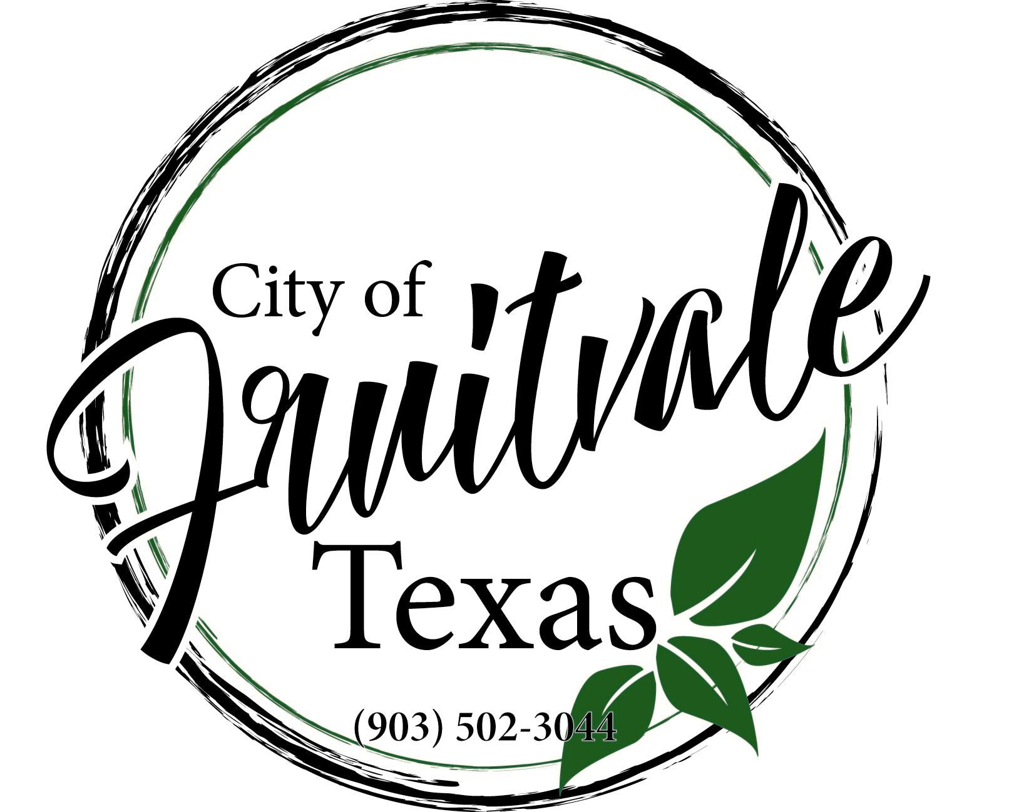
City of Fruitvale, TX
City Council Regular Meeting
October 8, 2024, at 6:30 p.m.
1063 VZCR 1129 Fruitvale, Texas

Council

Mayor – Susan Murre, Debbie Sheppard, Brandon Russell, Freda Jordan, Douglas Parker, Teri Brewer

Agenda

Call to Order/Invocation/Pledge of Allegiance
- Open Forum (Registered Speakers)

CDBG Contractor Award - Contract amount - $346,477.45 to Area Wide Paving, contract number - CDV23-0128

Presentation of TDA Form A1024 CDBG Section 3 Goals and Concepts as related to the CDBG Program and Grant Contract CDV21-0128.

Minutes

Financials

Fire Department Update

Annex Property

Community Center

Speed Bumps – 1918, 1910

Road Repair – 1128, 1901

AED

New Business

If the City Council, during the course of the meeting covered by this notice, should determine that an Executive Session is required then such Executive Session, as authorized by the Texas Open Meetings Act, Texas Government Code, may be held by the Council at the date, hour and place given in this notice, concerning but not limited to the following sections and purposes of the Act: Private consultations with the City Attorney – Article 551.071; Deliberations about Real Property - 551.072. Personnel Matters – 551.074; Conference with Employee – 551.075; Deliberation Regarding Security Devices – 551.076. Any final action; final decision or final vote shall be in the open meeting covered by the Notice upon the reconvening of the public meeting. A meeting that is “open to the public” pursuant to the Open Meetings Act, is one that the public is permitted to attend. The act does not entitle the public to choose the items to be discussed.

Adjourn
_________________________________________________
Susan Murre, Mayor

This is to certify that on this, the 5th day of October 2024 this notice was posted and accessible to the general public at all times and remained posted for at least 72 continuous hours preceding the scheduled time of the said meeting.

